



www.cqudefus.com

# About Us

1. Cqudefus is an information technology company formed by youthful professionals that aspire to help local businesses establish solid online presence. As young professionals exposed to the internet, we noticed a lot of gaps in the market which are under served.

This is where Cqudefus comes in. South Africa is behind in technology from the rest of the world and Cqudefus plans to change that by offering the latest technology, platforms applications and tools easily to all businesses.

# Background

## Company History

Cqudefus was informally formed by young professionals in 2016. The formation of the company was a result of seeing that there was a market within the technology industry which was being over looked. In 2017, the company was successfully registered. Our first massive client was a local radio station, Zibonele FM.

## What we do

Cqudefus is a technology company stresses the importance of innovation, quality and speed when getting the job done. At Cqudefus we create content, do hosting, and develop tools, platforms and applications to help businesses build their brand images in establishing online presence.

## Strategy and Vision

## Vision statement

Our vision is to have helped over 500 companies by 2030

## Mission statement

Our mission is to create content, develop platforms, applications and websites that provide value.

### Values

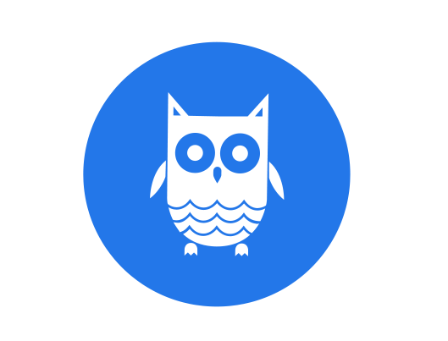

* Creativity
* Quality
* Detail
* Speed

### Business goals

* Revenue growth
* Sustainability
* Return on Investment

### Growth strategy

Our growth strategy is to utilize social media by giving educational value to the masses, giving growth value to influencers and brands.

# Products and Services

### Services

* + 1. **Brand identity** – We have a team of graphic designers. That have the eye of creative creation and meeting client’s expectation. Bring your idea into life
    2. **Development** – (Web , System , Mobile Development ) , With the large number of young programmers , we have power to create about anything we desire using computer technology
    3. **Hosting –** We have servers that can handle your hosting for you.
    4. **Domain –** You can obtain or buy Domain address from us
    5. **Content Creation –** With team of content creators ( Photographers) we can create content for you with your personal identity
    6. **Social Media –** We understand Social Media is the new Television, That’s where the attention is. We give you strategy on how you can win with Social Media for you brand.

### Business Competiveness

* + 1. Our Business Competiveness is that we take care of everything for you while you focus on your day to day business runnings.

# Management and Ownership

### Directors

* + 1. Liyolo Moko (Head Director)

Diploma in Information Technology Majoring in Programming at Cape Peninsular University of Technology (CPUT)

### Developers

* + 1. Athi Sithembiso (Developer)

Diploma in Information Technology Majoring in Programming at Cape Peninsular University of Technology (CPUT)

* + 1. Berka Ayowa (Developer)

Diploma in Information Technology Majoring in Programming at Cape Peninsular University of Technology (CPUT)

### Managers

* + 1. Linda Mayambela (Manager)

Bachelors in Entrepreneurship Majoring in Finance at Cape Peninsular University of Technology (CPUT)

1. Portfolio
   1. We have work with 1 client so far

Thank you for taking the time to read our company profile.

If there are any questions or comments, please feel free to contact us.